

**NATIONAL CERTIFICATE**

# INDUSTRIAL INSTRUMENTS N5

(8080205)

**17 April 2020 (X-paper) 09:00–12:00**

**This question paper consists of 5 pages and a formula sheet of 2 pages.**

## 299Q1A2017

Please turn over

### DEPARTMENT OF HIGHER EDUCATION AND TRAINING

**REPUBLIC OF SOUTH AFRICA**

NATIONAL CERTIFICATE

INDUSTRIAL INSTRUMENTS N5

TIME: 3 HOURS

MARKS: 100

#### INSTRUCTIONS AND INFORMATION

1. Answer all the questions.

1. Read all the questions carefully.

1. Number the answers according to the numbering system used in this question paper.

1. Use only a black or blue pen.

1. Write neatly and legibly.

**SECTION A: FLOW MEASUREMENTS**

#### QUESTION 1

1.1 Two water pipes of different diameters both have blunt objects (bluff bodies) in the paths of their respective water flow. A pressure-sensor device located near each of the bluff bodies measures the frequency of vortices produced.

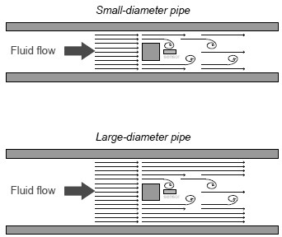



If the bluff bodies in both pipes have the same physical dimensions, and the vortex-shedding frequencies are the same in both scenarios, which pipe, if any, carries a greater volumetric flow rate of water? Give a reason for the

answer. (6)

1.2 Name TWO parts of a flowmeter.  (2)

1.3 Give TWO ways of setting up pressure so that fluid can flow. (2)

**[10]**

#### QUESTION 2

2.1 If a pipe goes from a 9 cm diameter to a 6 cm diameter and the velocity in the

9 cm section is 2,21 m/s, what is the average velocity in the 6 cm section? (6)

2.2 A swirl flowmeter is a velocity-sensitive device that measures the volumetric flow of gasses and liquids.

2.2.1 Make a neat, labelled sketch of a swirl flowmeter. (6)

2.2.2 Give THREE advantages and THREE disadvantages of a swirl

flowmeter. (3 + 3) (6)



2.2.3 Show, by means of a labelled sketch, how pressure and

temperature are compensated when using a swirl flowmeter. (6)

**[24]**

**TOTAL SECTION A: 34 SECTION B: DENSITY, HUMIDITY AND VISCOSITY**

#### QUESTION 3

3.1 Explain the operating principle of a displacement hydrometer. (5)

3.2 Explain, with the aid of sketches, Newtonian and non-Newtonian fluids. (3 + 3) (6)

3.3 Explain the mounting place of a hair hygrometer. (8)



3.4 Although there are several circuits used for measuring electrical conductivity, a Wheatstone bridge is most widely applied and is potentially the most stable and accurate.

3.4.1 Draw a neat, labelled measuring circuit for conductivity

measurement. (6)

3.4.2 Explain how automatic compensation can be performed in a

conductivity-measuring circuit. (3)

**[28]**



**TOTAL SECTION B: 28**

**SECTION C: pH MEASUREMENT**

#### QUESTION 4

4.1 Why is screening and earthing important in pH measurement? (3)

4.2 What is the main purpose of a reference electrode? (3)

4.3 If the pH meter registers an alkaline solution, would there be an abundance of

hydrogen ions or hydroxyl ions? (2)



4.4 Briefly explain, with the aid of a drawing, the measuring principle of a pH

glass-membrane electrode. (10)

**[18]**

**TOTAL SECTION C: 18**

**SECTION D: AUTOMATIC CONTROL**

#### QUESTION 5

Use the sketch of a pneumatic receiver controller below and answer the questions.

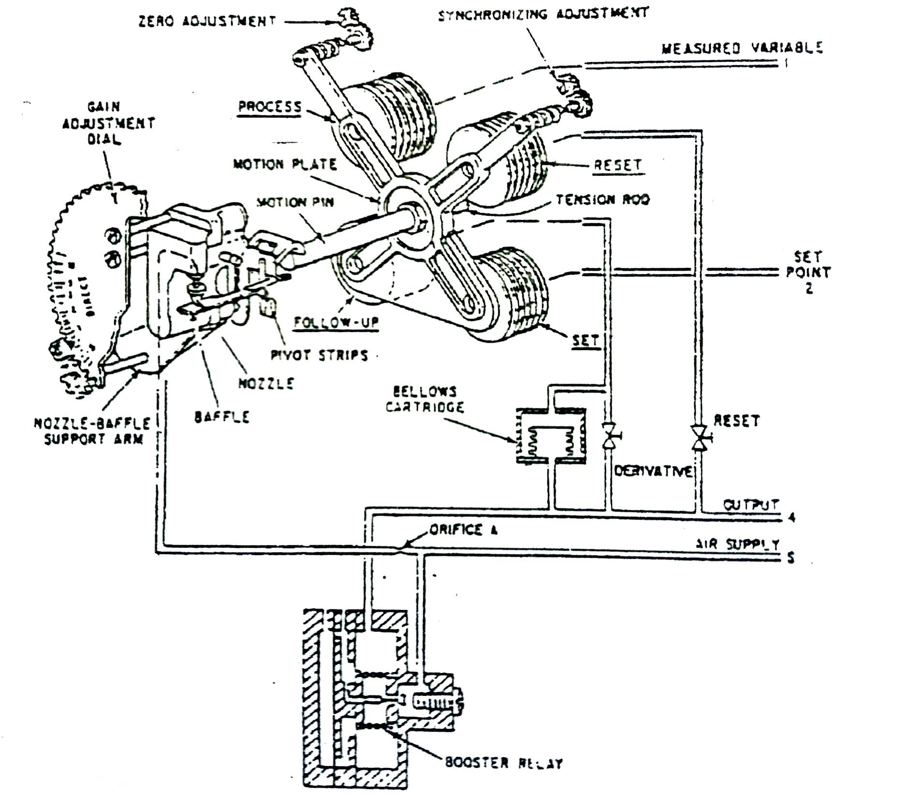



5.1 Which conditions apply when the controller is balanced?  (3)

5.2 Which conditions apply if the measured variable increases by 10 kPa?

The gain adjustment is 1,0 and no reset (integral) or derivative (rate) action is

generated. (5)

5.3 What is the proportional band of the controller if the gain setting is as in

QUESTION 5.2? (1)

5.4 How would one reverse the action on this type of controller? (1)

5.5Explain what is means when the integral action of a controller is marked r/min. (3)

5.6 Explain the terms *derivative action time* and *integral action time*.  (3)

5.7 Give THREE advantages of a live zero-based signal and ONE advantage of a zero-based signal controller as used in an electronic controller. (4)

**[20]**

**TOTAL SECTION D:**  **20** **GRAND TOTAL:**  **100**

-1-

#### FORMULA SHEET

2

)

(

ρ

*h*

2

(

)

ρ

*h*

2

(

)

ρ

*h*

2

(

)

ρ

*h*

(

)

ρ

*h*

W = 359≅2CZ,Ed

Q = 359≅2CZ,Ed

W = 0≅01252CZ,Ed

Q = 0≅01252CZ,Ed

Qg = 2238CZEd2

m = (d/D)2

*W Q* ( )ρ

*N*

001252

()

001252

(

)

2

2

*D*

*h*

*D*

*h*

⋅

=

⋅

=

ρ

|  |  |
| --- | --- |
| mE = N/CZ, | CmE = N/Z, |
| m = (d/D)2 | E = 1/ (1− *m*2) |

*W Q*ρ *Qg*ρ *Rd* = = =

Rd = W/15≅8 µd

Rd = Q∆/15≅8 µd

Rd = 3≅54 W/µd

Rd = 3≅54 Q∆/µd

Rd = Qg∆/98≅6 µd

E = 1/ (1− *m*2)

mE = CmE/C

15 8⋅ µ*D m*( ) 15 8⋅ µ*D m*( ) 98 6⋅ µ *D m*( )

*W Q* ( )ρ *Qg* ( )ρ

*N* 2

3592

()

3592

()

2

2

*Dh*

*D*

*h*

*D*

*h*

=

⋅

=

⋅

=

2238 ( )

*d D*/ = [(*mE*)2/1+ (*mE*) ]2 mE = N/CZ,

W = 1890 Ud2 (ρ*P*) for critical flow

CmE = N/Z, mE = CmE/C

*d* = [*W*/1890*U* (ρ*P*)]for critical flow

354⋅ *W* 354⋅ *Q*ρ 2 2

*Rd* = = *dD*/ = [(*mE*) /1 + (*mE*) ] µ*D m*( ) µ*D m*( )

Please turn over

-2-

*W* =1252⋅ *Ud*2 (ρ*P*) for critical flow

*d 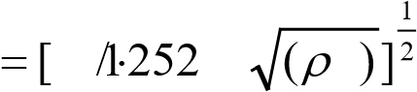W U P*  for critical flow

1 kPa = 102 mmWD = 102 mmWG

1 lb/ft3 = 16,0183 kg/m3

Atmospheric pressure = 101,325 kPa

Gravitation acceleration = 9,81 m/s2

For D + D/2 tappings and flange tappings

*h kPa*

× 27,2 = × 27,2

*Pa kPa*

*Q* =  tan  2 .*gH*5

Copyright reserved

*Q* =  *B* 2 .*gH*3